Neosha Allen
9/7/2026
Module 5.2 Assignment
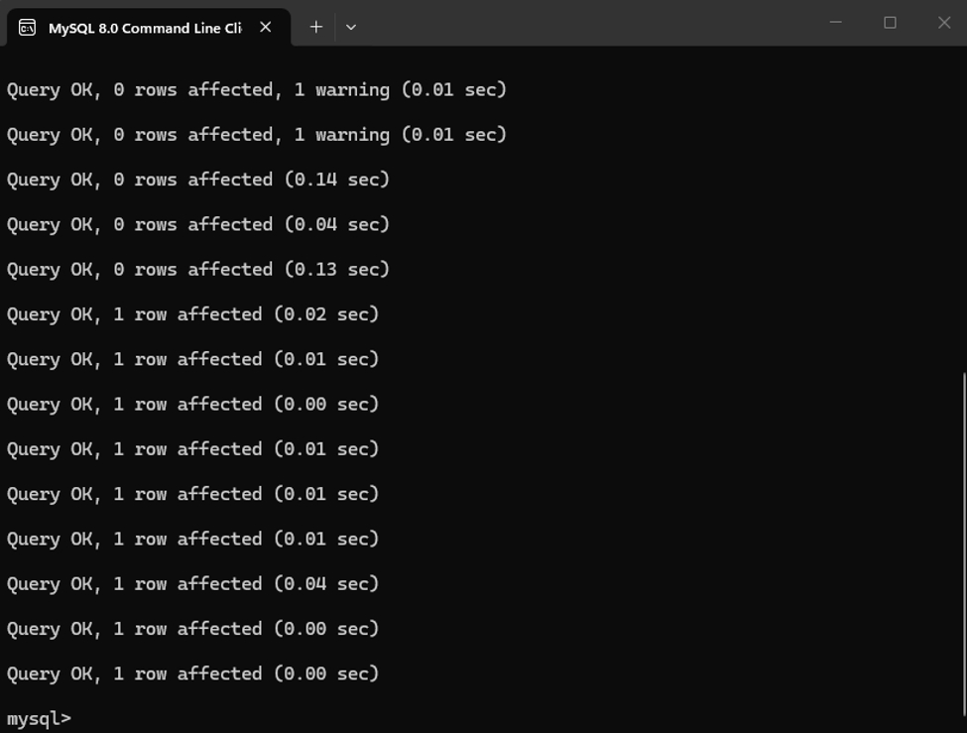
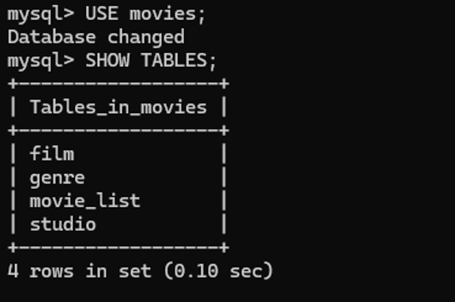
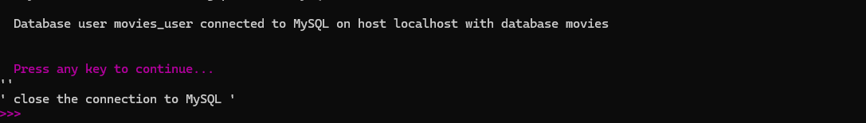
https://github.com/allenneosha/csd-310/tree/main/module-5

